**D11.4 Report on Use Cases, Requirements, Metadata and Interoperability of WP 11**

**Document information Summary**

|  |  |
| --- | --- |
| **Date** | 30.03.2018 |
| **Document title:** | D11.4 Report on Use Cases, Requirements, Metadata and Interoperability of WP 11 – M30 |
| **Leader Partner** |  |
| **Main Author(s):** | Tim Sonnemann, Danilo Reitano, Philippe Labazuy, Arnaud Lemarchand |
| **Contributing author(s):** | Adelina Geyer Traver, Carlos MS. Primo, Kristin S. Vogfjörð, Giuseppe Puglisi |
| **Reviewer(s):** |  |
| **Approved by:** |  |
| **Target audiences:** |  |
| **Keywords:** | Status report, WP11, EPOS |
| **Deliverable nature:** | Report |
| **Dissemination level:** | Internal use |
| **Delivery date:** | 30.03.2018 |
| **Version:** | 2.0 |

**TABLE OF CONTENTS**

Table of tables 3

SUMMARY 5

1. Introduction to the TCS 5

2. Revised DDSS Priority list 10

3. Harmonization and new metadata standards 10

4. Testing candidates for WP6/7 10

5. Status of the roadmap 11

6. Data Management Plan (DMP) 13

7. “VULKAN” – The Volcanology Gateway 14

# Table of figures

Figure 1: Volcano observations - TCS organization 4

Figure 2: FutureVolc Supersite Portal 13

Figure 3: HotVolc Observing System 13

Figure 4: Med-Suv Supersite portal 14

Figure 5: TDS System portal 14

# Table of tables

Table 1: Institutes, Location, Contact and Major offerings information 6

Table 2: List of WP11 Data 10

# SUMMARY

This report is the second revision of the D11.4 report delivered in March 2017. The main changes in this version of the report are the following:

* The DDSS Priority list has been revised and modified
* The status of harmonization and development of new standards is given
* An updated roadmap for work to be done before M36 is presented
* The status of the Volcanology Gateway is given
* Comments on use cases, testing and validation are given

# 1. Introduction to the TCS

Volcano observations is the theme for this TCS and Work Package 11. The WP11 TCS is organized in a layered structure, where at the lower level there are the national/local DDSS providers as seen in figure 1.

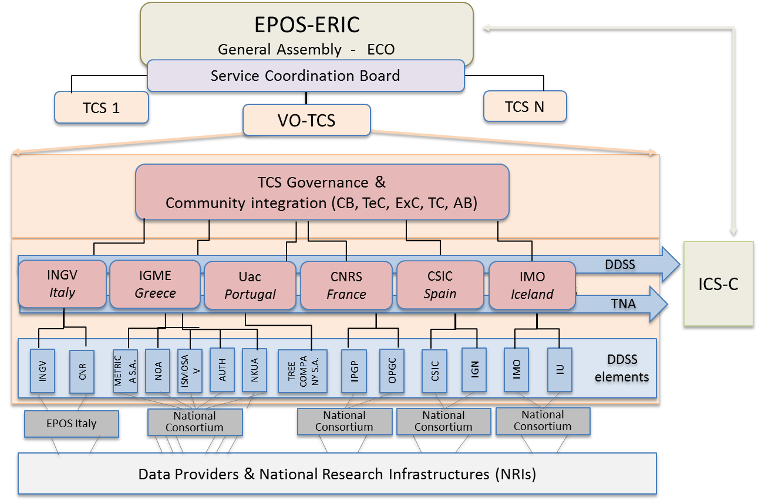Figure 1: Volcano observations - TCS organization

At the date of this writing, the candidate service providers (i.e. those that declared to be able to provide DDSSs) are INGV, IMO, CSIC, CNRS, IGME and UAc.

* **INGV**, based in Italy, manages two volcano observatories (Osservatorio Vesuviano and Osservatorio Etneo), and include several laboratories and modelling centres.
* **IMO**, based in Iceland, manages the monitoring of Icelandic volcanoes and include also the contributions of the local university.
* **CSIC**, based in Spain, is a research institution that includes also the data provided by the monitoring system of the Canary Island, managed by IGN.
* **CNRS** is based in France and consists of two third parties: IPGP and OPGC. Through the IPGP it manages three volcano observatories (Observatoire Volcanologique et Sismologique de la Martinique, Observatoire Volcanologique et Sismologique de la Guadeloupe, Observatoire Volcanologique du Piton de la Fournaise) and OPGC contributes to the national volcano monitoring systems. Both include several laboratories and modelling centres.
* **IGME**, based in Greece, provides the observation relevant to Santorini volcano.
* **UAc**, based in the Azores, Portugal, provides the observation relevant to the monitoring system of the volcanoes of the Azores Islands, managed together with CIVISA.

Beside this list, there are three further participants to WP11, one of which has declared some DDSS at a medium/low priority:

* **GFZ** (EPOS-IP full partner)
* **DIAS** (Dublin Institute for Advanced Studies; IR)
* **UB** (University of Bristol; UK) as EPOS-IP Contributing Institutions.

All services providers, except for INGV, are national Research Infrastructures (RIs) that manage DDSSs implemented either in their own activities or provided by other national RIs, to which they are linked by specific agreements.

In the DoA the data (Level 0,1) and belong to the following disciplines:

* seismology
* geodetic
* geochemistry (e.g. gas emission)
* volcanology (e.g. rock/ash)
* environmental (e.g. meteorological in co-located geochemical/geophysical stations)

Then there are also multidisciplinary volcanic and hazard products (Level 2, 3):

* geo-volcanological maps
* chemical/physical data on rocks
* ashes
* fluids
* eruptive parameters
* thermal characteristics of lavas
* eruption rates

Currently, there are five candidate service providers contributing to this TCS, providing a variety of DDSSs, e.g. time series, data plots, terrestrial /spatial images, and volcanic maps. This can be seen in Table 1 here below which also provides information on institutes and contact persons.

Table 1: Institutes, Location, Contact and Major offerings information

|  |  |  |  |
| --- | --- | --- | --- |
| **Institute** | **Location** | **Contact person(s)** | **Major function / offerings** |
| **INGV**   * **Osservatorio Etneo** * **Osservatorio Vesuviano** * **INGV Pisa** | Italy | Giuseppe Puglisi  *giuseppe.puglisi@ingv.it*  Danilo Reitano  [*danilo.reitano@ingv.it*](mailto:danilo.reitano@ingv.it) | 1. seismology 2. geodetic 3. environmental 4. geochemistry 5. potential fields 6. remote sensing 7. volcanology |
| **UAc** | Azores | Teresa JL. Ferreira  *Teresa.JL.Ferreira@azores.gov.pt*  Carlos Primo *Carlos.MS.Primo@azores.gov.pt* | 1. seismology 2. geodetic 3. environmental 4. fluid geochemistry 5. remote sensing 6. petrology |
| **CNRS**   * **IPGP** * **OPGC** | France | Aranaud Lemarchand (IPGP)  *arnaudl@ipgp.fr*    Philippe Labazuy (OPGC)  *P.L*[*abazuy@opgc.fr*](mailto:p.labazuy@opgc.fr)  *Yannick Guéhenneux (OPGC)*  *Y.Guéhenneux@opgc.fr* | 1. seismology 2. geodetic 3. environmental 4. fluid geochemistry 5. potential fields 6. remote sensing 7. petrology |
| **CSIC / IGN** | Spain | Adelina Geyer Traver (CSIC) [*ageyertraver@gmail.com*](mailto:ageyertraver@gmail.com)  Carmen Lopez (IGN) [*clmoreno@fomento.es*](mailto:clmoreno@fomento.es) | 1. seismology 2. geodetic 3. environmental 4. fluid geochemistry 5. potential fields 6. remote sensing 7. petrology |
| **IMO** | Iceland | Kristín Vogfjörð  *vogfjord@vedur.is*  Fjalar Sigurðarson  [*fjalar@vedur.is*](mailto:fjalar@vedur.is) | 1. seismology 2. geodetic 3. environmental 4. geochemistry 5. remote sensing 6. petrology 7. volcanology |

# 2. Revised DDSS Priority list

The DDSS Priority list has gone through heavy revision since last year, both regarding number of DDSSs presented and in the work of the harmonization groups. The maturity of each DDSS has been evaluated to measure the probability of success for implementation of all the DDSS. This was done with the help of the IT survey and a tool (quantitative) called **Maturity Scorecard** that was main part of D11.4 - M18 report.

In short, the results of all the revisions are that the estimated likelihood of success has been lowered for many of the items from high to medium, and even to low. In other case items have been simplified and multiple items have been merged into one item with new description due to similar properties and nature, specifically regarding metadata.

Some of those DDSS are under the authority of other work packages which means WP11 depends in some cases on deliverables and solutions of other WPs. An example of this is still the GLASS framework which WP10 is developing for GNSS data and products. It is possible that some institutes will use their existing IT infrastructure to make data available, which means less dependency on solutions from other WPs but in some case delays in delivery in other WPs may affect WP11. The possible extent of this is not presently clear.

The current **revised** DDSS Priority list for WP11 contains the providers (institutes) and the items each one will provide access to before M24. Summary tables for each item type can be found in chapter 5.

# 3. Harmonization and new metadata standards

The work of the harmonization groups inside WP11 is relevant on assessing the metadata came from the HGs that WP11 has lead: examples are HG-09 on Geochemical Data and HG-11 on Analog and Numerical modelling. Other input was provided by the WP11 team on the hazard product.

At present, after the technical meeting in Lisbon, a WP6/ WP7 proposed a new guideline within the scope of interoperability with TCS and ICS developing EPOS-IP Portal. The proposal regards an update of DCAT-AP versus Resource Description Framework (RDF) format. Technical aspects and operating tests are still under evaluation. It is clearly required to each TCS to be an active part of this process. This issue will be defined in the forthcoming months.

# 4. Testing candidates for WP6/7

As already presented in D11.4 - M18, WP6/7 asked to each work package to submit to ICS some DDSSs as testing candidates. The following DDSSs have been proposed by the IT group and submitted to the ICS evaluation. At the end of 2017 only two services have passed the validation phase, but now the whole set has been completed.

* Thermal anomaly (lava flow) (CNRS-OPGC)
* Chemical analysis and physical properties of gas, water and rocks (CNRS-OPGC & INGV)
* Velocity Seismic Waveforms (CNRS-IPGP)
* Wrapped Differential Interferograms (INGV)

All service interface information has been collected and shared with WP6/7.

# 5. Status of the roadmap

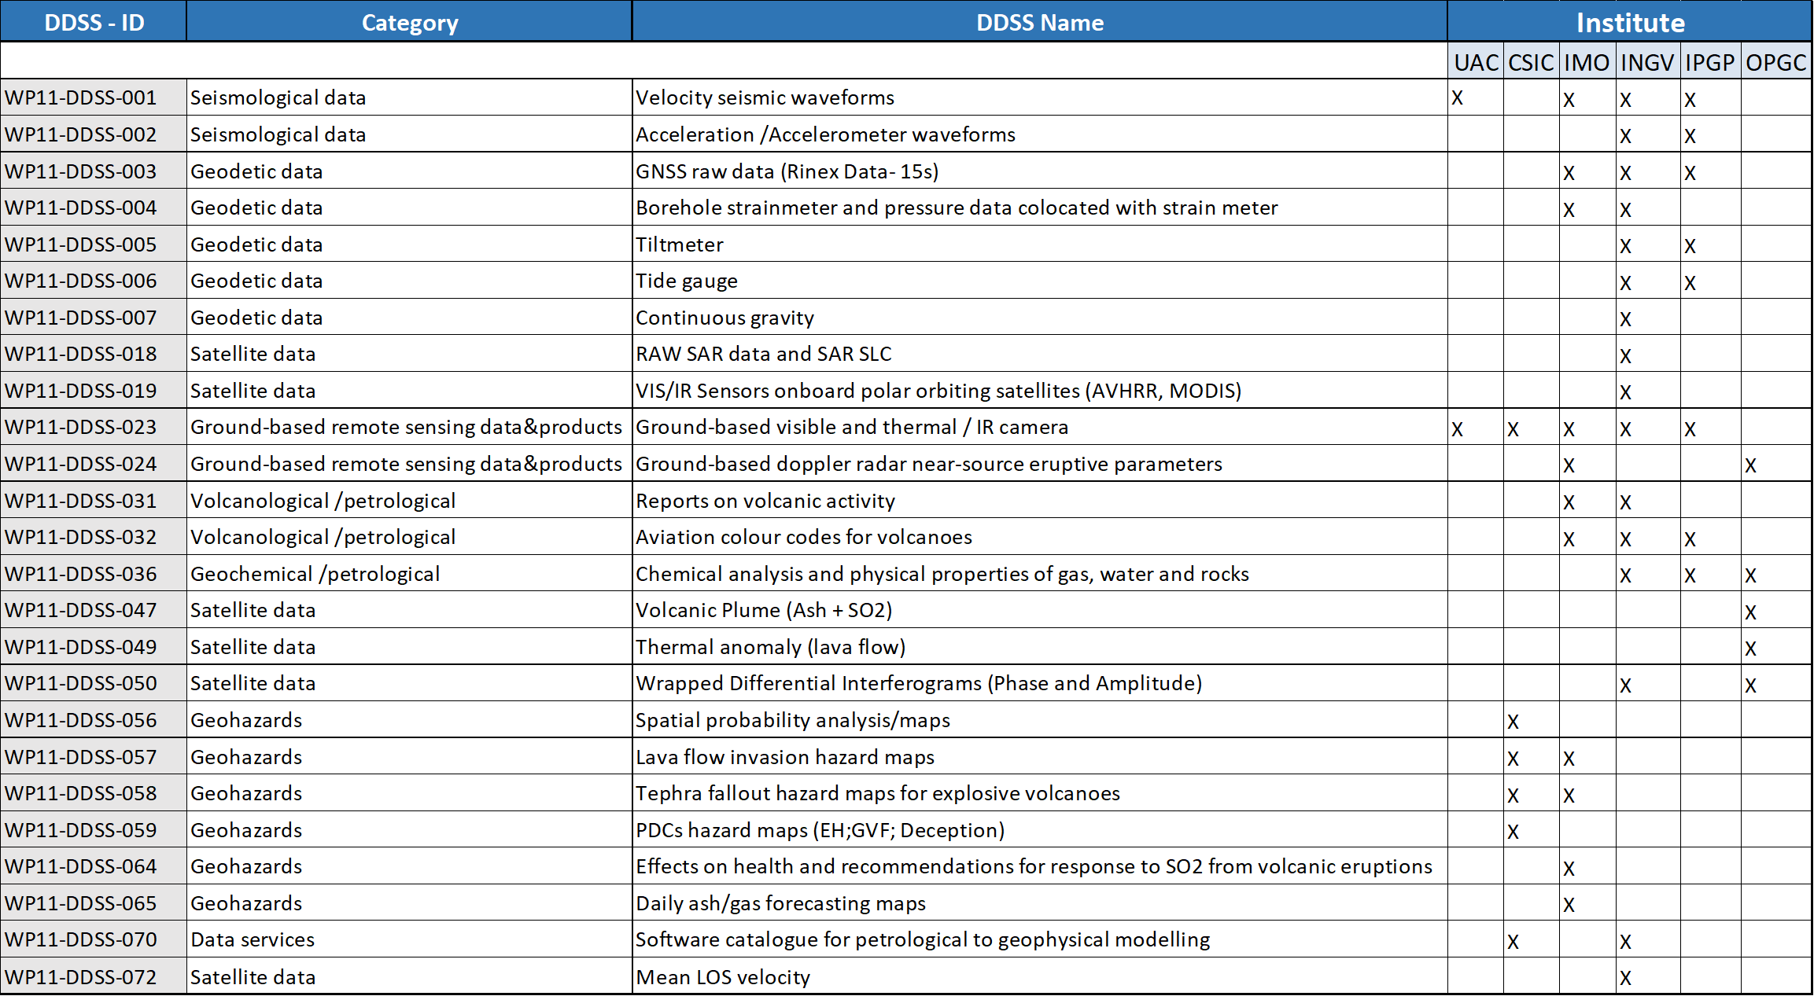

Table 2: List of WP11 Data, Data Product, Services and Software that will be released at the end of 2018.

The Table2 reports all elements under actual implementation, WP11 plans to provide them until the deadline of December 2018. We consider to make two WP11 internal control steps in July and September 2018.

Some of them are now up and running inside single service providers’ portal, but they were not prioritized in previous deliverable document. Many others are under harmonization with EPOS-IP metadata standard request. By the end of the year we propose the following steps:

* Continue implementation in cooperation with WP6/7
* Schedule and execute testing of services when available and notify WP6/7
* Announce available services when tested and ready.

# 6. Data Management Plan (DMP)

The Data Management Plan (DMP) of the TCS “Volcano Observation” will provide an analysis of the main elements of the data management policy with regard to all data sets (i.e. DDSS proposed by the TCS “Volcano Observation”) that will be delivered in the framework of EPOS. The DMP will not be a fixed document, but will evolve during the lifespan of the project. The DMP will address the points below on a data set by data set basis and will reflect the current status of reflection within the consortium about the data that will be distributed *(source: European Commission DGRI. 2016. Guidelines on Data Management in Horizon 2020)*.

* **Data set reference and name** ‐ Identifier for the data set to be delivered.
* **Data set description** ‐ Description of the data that will be delivered, its origin, nature and scale and to whom it could be useful, and whether it underpins a scientific publication. Information on the existence (or not) of similar data and the possibilities for integration and reuse.
* **Standards and metadata** ‐ Reference to existing suitable standards of the discipline. If these do not exist, an outline on how and what metadata will be created.
* **Data sharing** ‐ Description of how data will be shared, including access procedures, embargo periods (if any), outlines of technical mechanisms for dissemination and necessary software and other tools for enabling re‐use, and definition of whether access will be widely open or restricted to specific groups. Identification of the repository where data will be stored, if already existing and identified, indicating in particular the type of repository (institutional, standard repository for the discipline, etc.). In case the dataset cannot be shared, the reasons for this should be mentioned (e.g. ethical, rules of personal data, intellectual property, commercial, privacy‐related, security‐related).
* **Archiving and preservation (including storage and backup)** ‐ Description of the procedures that will be put in place for long‐term preservation of the data. Indication of how long the data should be preserved, what is its approximated end volume, what the associated costs are and how these are planned to be covered.

A first version of VO-TCS DMP has been implemented in the D11.5 (Annex 3). A further revision is planned by September 2018.

# 7. “VULKAN” – The Volcanology Gateway

As already described in D11.4 - M18 active volcanoes are quite different from other geological environments and the relevant data needs to be characterized and organized according to specific approaches and exploiting the experience of a large community. The European volcano observations community, represented by Volcano Observatories (VO) and Volcano Research Institutions (VRI) participating to the EPOS-IP project, will implement services to enable open access to data, data products, software and services (DDSS) provided from the community. Technical implementation of these services starts from the Volcano Observations Thematic Core Service (VO-TCS), which will coordinate activities among the contributing VOs and VRIs to ensure their interoperability with the EPOS Integrated Core services (ICS) and will be realized in the first European volcanic portal.

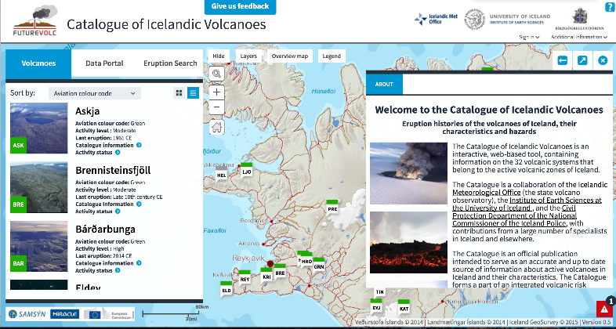

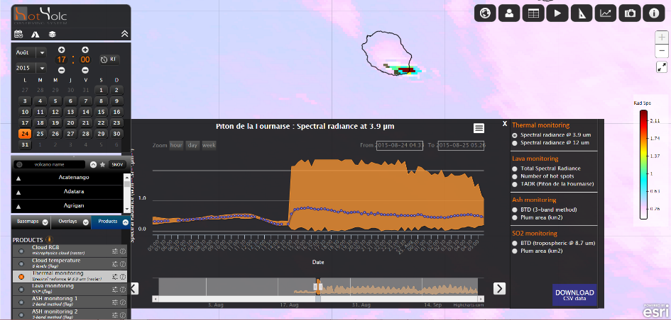Figure 2: FutureVolc Supersite Portal

Figure 3: HotVolc Portal

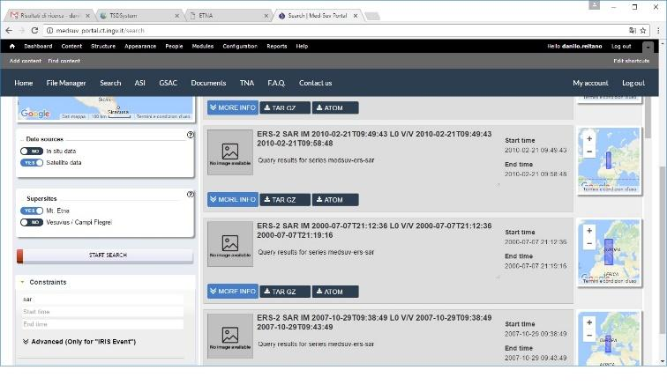The role of the developing gateway is to harmonize different kind of data, products and service and create multidisciplinary environment, supporting specifically standards widely used by the community of European researchers.

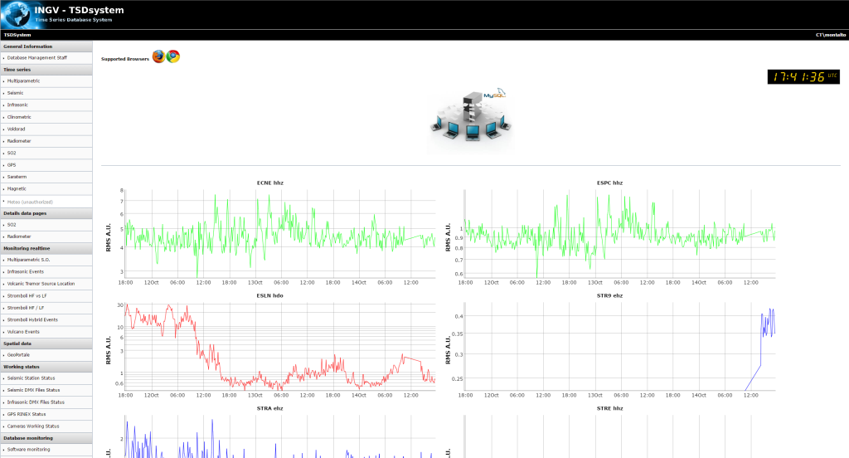Figure 4: Med-Suv Supersite Portal

Figure 5: INGV - TSDSystem Portal

After different conceptual evaluations regarding the development of the VO-TCS Vulkan Gateway, some useful implementation features have been discussed inside the IT group. At the end, it has been decided to develop, in a first implementation phase, the Web Site Portal infrastructure, in order to federate all the existing services inside each Service Provider’s Portal. Different users (also EPOS-IP users) will find all available descriptions for each DDSS element distinguishing those which are discoverable also inside EPOS ICS Web infrastructure. ICS automatic software will also discover the available metadata through the Rest Services server/servers.